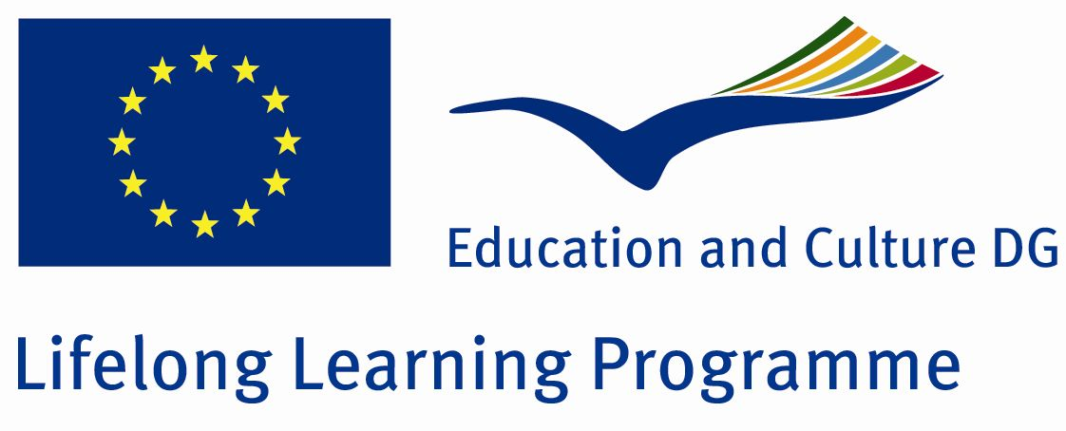
Scoala cu clasele I-VIII nr.8
Sibiu, str. Lupeni nr.50
Tel: 0269237225
Comenius Project “How Healthy Is Europe”

Nr. 11-PM-1072-SB-UK
Activity report

1.Title: Walk around Europe

2.Teacher: Creteanu Dana

3.Date:19.06.2012

4.Activity:1 h

5.Students:15 students from the 2nd grade up to the 6th grade

6.Aims
The interpretation of the obtained results while doing the activity with the pedometers, from January to May.
Realizing as final products their own foot drawn on a paper and write down both the number of the steps and their transformation to meters and kilometers for each month.

7. Resources:

a) humane: students and teacher
b) material: white paper, colored paper, glue, camera, colored labels

8. Activity description:
- the presentation of the number of steps realized from January to May 2012;
-to do the configuration of ones foot (each student draw his own foot and then cut the paper to have the right shape);
-count the final number of steps and transform them to meters and kilometers;

.8.Results:
-The interpretation of the number of the steps;
-The hand outs containing the data about the number of steps.
-The students received awards.


