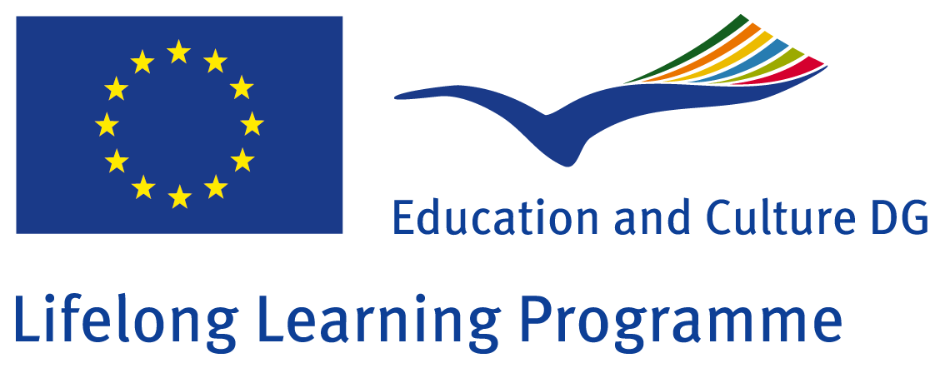

Research on United Kingdom

Scoala cu clasele I-VIII nr.8 Sibiu
Class: 23 students
Teacher: Micu Andreea

The research on United Kingdom, one of our partners from the Comenius Project “How Healthy is Europe”, was done during classes by the students from grade 5 B.
Introduction:
Students were told to do some research back home, with the help of parents, from books and with the help of the internet and technology about United Kingdom and London. They had to bring the information they collected to school. Each student was supposed to be very careful in selecting the information, to find the most interesting and unusual ones.
It was a great opportunity to exchange information, to work in groups and to stand in front of the class proud to present the work done by them.
It was also a good opportunity for the students to learn how to summarize and how to use information in a project, to analyze which sources are trustful and which not.

The activity:
Students worked in group, made a presentation of their work and then presented in front of the school. After presenting their work, the students exposed it in the classroom.

The end of the activity:
Students organized a corner in their classroom with interesting information they found about United Kingdom and London.


