Scoala cu clasele I-VIII nr.8 Sibiu 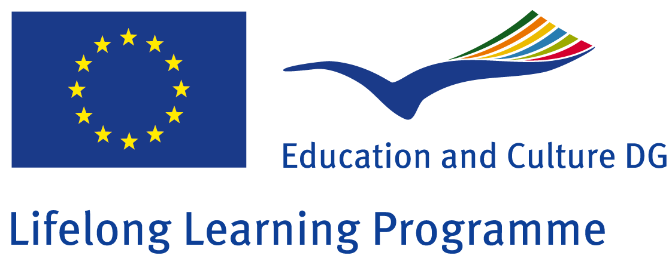

Comenius project
Research on the countries participating in the project „How Healthy is Europe”
Class: II A
Teacher: Chirhoc Mariana Eugenia

ROMÂNIA

Aims:
-the students should discover the place of Romania on the map of Europe;
-the students should discover the colors of the Romanian flag and what the colors stand for;
-the students should be able after analyzing the map of Europe to identify the neighbors of Romania
-the students should know to show on the map the capital of the country and to indicate the different zones in Romania;
-the students should discover the number of inhabitants and the country surface;
-the students should be able to indicate their own hometown, Sibiu on the Romanian map
-the students should analyze and observe the local customs;
-the students should be able to name some of the main sights of Sibiu.

The students of the II.A grade had as topic the discovery and analyze of their own country, the country they live in and learn in.
The main objectives of this activity were achieved. The students were able to present their research in front of the class. They worked in groups, which made their work easier and funny. For achieving the aims of the activity, there had been used maps, leaflets, pictures, advertising materials, plasticine and colored paper.

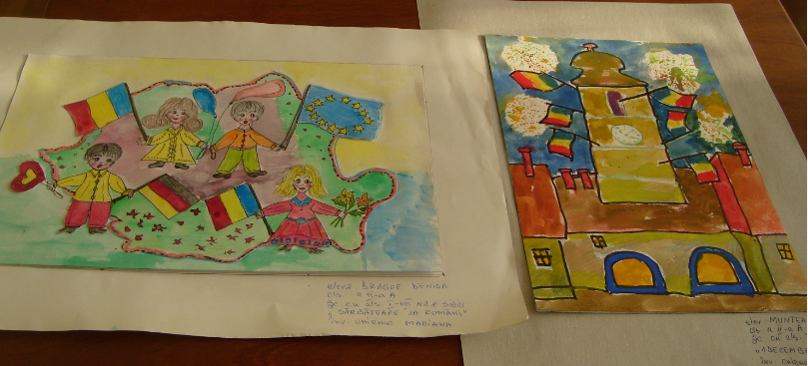
Here are some drawings done by the students from the II. Grade.
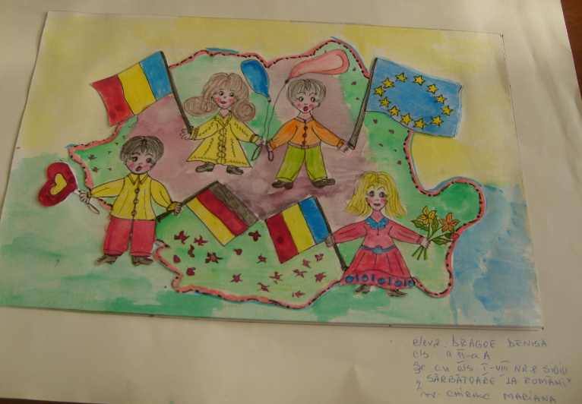

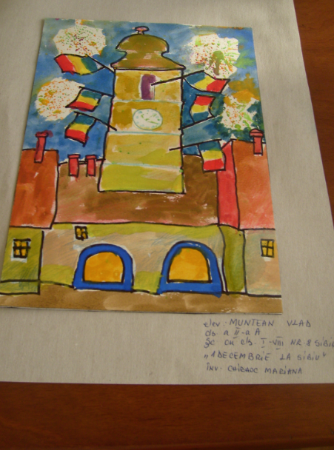
The result of the students work is to be seen in the classroom, on the wall dedicated to Romania.


