Scoala cu clasele I-VIII nr.8 Sibiu 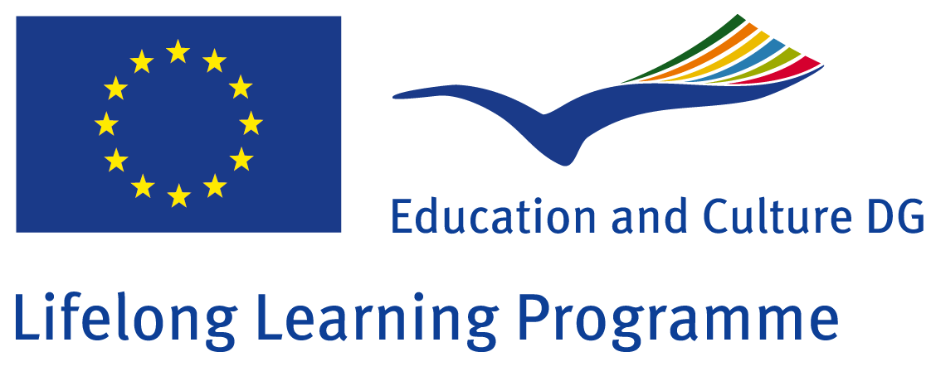

Comenius project
Research on the countries participating in the project „How Healthy is Europe”
Class: II B
Teacher: Perju Maria

Poland

The students of the II.B grade had as topic the discovery and analyze of Poland
The class was divided into 4 groups, each group had a task.
I. Group: to find Poland’s map and to analyze it. They had to manufacture 8 Romanian flags;
II. Group: to manufacture 8 Polish flags;
III. Group: to collect information about Poland;
IV. Group: to collect photos from Poland, famous places and building;

-After 1 week, the materials were collected by the teacher.
-Together with the teacher did the students arrange the special corner in the classroom dedicated to Poland.
-At the end, after all materials were on the wall, the students had to present their work and their discovery for all the others in the classroom.
-The final act, was for the students, each holding a Romanian or a Polish flag in their hands, to shake hands symbolizing the friendship between the countries.

The result of the students work is to be seen in the classroom, on the wall dedicated to Romania.


