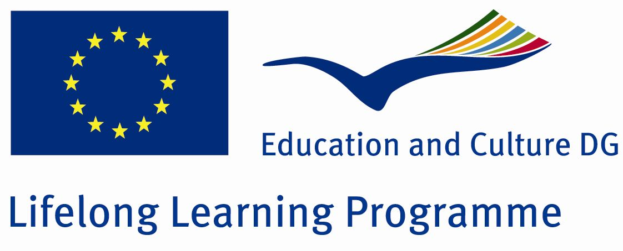
Scoala cu clasele I-VIII nr.8
Sibiu, str. Lupeni nr.50
Tel: 0269237225

Comenius Project “How Healthy Is Europe”
Nr. 11-PM-1072-SB-UK
Activity report

1Title: Sport – Kayak Canoe

2 Teacher. Ene Camelia

3 Date:23.03.2012

4 Activity: 45 min

5 Students: class a I a B

6 Aims
- Students should understand the importance of sport for our health;
-Students should realize the importance of healthy food and sport activities for a healthy body.

7 Resources :
a) humane: students from the I B grade, teacher;
b) material: school’s library, texts about sport, information and pictures from the internet.

- Activity description:

During this class the attention was on the information about sport activities, about healthy food and healthy life style.
Health = the most precious possession
Kayak Canoe = presentation, history, representative sportsmen
Olympic gainer: Ivan Patzaichin

- Results:
To develop the interest of sport practicing among students;
The presentation of different sports and the development the general knowledge among students;
- Final result:
-classroom panel



